Soccer Study Sheet

What a Soccer Field Looks Like
A soccer field (sometimes referred to as “the pitch”) is at least 100 yards long, 50 yards wide, and has a goal centered at both ends. Within the field are markings including those for the penalty area and spot, the center spot for kick-offs, and, of course, the corners — without which corner kicks would just be kicks.
The field of play is divided into two halves by the halfway line, which joins the middle of both touchlines. In the middle of this halfway line is the center mark commonly referred to as the center spot. Around it is marked a circle with a 10-yard radius.
The field can be constructed of grass, or it can be composed of manmade materials such as AstroTurf. The color of any artificial surface must always be green. The following figure shows the correct layout for a regulation soccer field:

Positions on a Soccer Team
Each soccer team has 11 players — 1 goalkeeper and 10 field players. Every player, whether playing an offensive or defensive position, works to help the team score goals — and to prevent the other team from scoring. The following list explains the role of each general position on the field:
- Goalkeeper: The keeper is the only player allowed to use his hands, and that activity is restricted to the rectangular penalty area extending 18 yards from each side of the goal.
- Defenders: They play in front of the goalkeeper, and their primary duty is to stop the opposition from scoring. Outside fullbacks play on the left and right flanks and rarely move from their sides of the field. Central defenders play in the middle of the field and usually cover the opposition’s leading goal scorer or center forward(s).
- Midfielders: These players are the link between the defense and attack. Midfielders must be the most physically fit players on the field because they are expected to run the most in a game. They should be able to penetrate deep in enemy territory on attack and make the transition to defense when the opposition retains possession of the ball.
- Forwards: Their primary job is to score goals or to create them for teammates. A center forward, also known as a striker, should be a team’s leading goal scorer and the most dangerous player in the attacking third of the field.

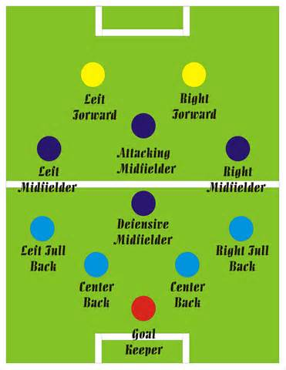

What Is the Offside Rule in Soccer?
The offside rule is the most debated soccer principle (no matter where the game is played), even though what is known as Law 11 isn't terribly difficult to grasp. Here’s what offside is all about:
A player is caught offside if he’s nearer to the opponent's goal than both the ball and the second-last opponent (including the goalkeeper) when his team-mate plays the ball to him. In other words, a player can’t receive the ball from a team-mate unless there are at least two players either level with him or between him and the goal or unless his team-mate plays the ball backwards to him.
It’s not an offense in itself to be offside. A player is only penalized for being offside if he is deemed to be involved in active play. So a player can only be called offside if he is:
- In the opposition’s half.
- Interfering with play (that is, he’s part of the attacking move).
- Interfering with an opponent (that is, he’s preventing the opponent from defending against the attacking move).
- Gaining any advantage by being in that position.

